Hasty Industrialization and the Predictable Displacement of Transient Populations
Logan Albert Kyger

ARC435 Critical Inquiry, Spring 2026
May 8, 2026

Abstract
The rapid industrialization and urban renewal of The Zone in Phoenix since 2023 have intensified the presence of homelessness in Downtown Phoenix. By concentrating new shelters in the former settlement area, The Zone, the project excluded many unhoused people, particularly those with substance use issues; it also pushed them into the urban core. This research examines how architectural and infrastructural decisions drive predictable patterns of displacement and informal resettlement. It frames hasty urbanization as a form of slow violence that produces long-term spatial harm. Through site mapping, interviews, economic analysis, and comparative study, this project reveals how new developments both displace vulnerable populations and inadvertently create habitable common spaces that homeless people adaptively reuse. In Phoenix’s extreme heat, where concrete surfaces reach 150–170°F, shade, foot traffic, and survival resources shape resettlement patterns. This work calls on architects to redefine industrialization practices, predict downstream effects, and design inclusive urban systems to reweave displaced people into the city rather than push problems elsewhere. Architects need to view their future constituents with the same level of importance that they view their current constituents. As the housing crisis deepens and the Southwest grows hotter, such foresight is essential for building a resilient city that serves all residents.

This research paper was heavily informed by the work of Dagmar Pelger (Spatial Commons), Rob Nixon (Slow Violence), and Biao Xiang and Johan Lindquist (Migration Infrastructure.)

1.0 Introduction
Over the course of this semester, I have developed a deep interest in homelessness and the displacement of populations our society renders invisible. During an early site visit with my classmates in Downtown Phoenix for my third-year design studio project, I witnessed firsthand the downstream effects of the immediate history and harsh realities of homelessness in the area. I saw at least forty unhoused individuals near my studio site, many clustered in whatever shade they could find or lingering near high-traffic areas in search of basic survival resources. This experience profoundly affected me. It led me to center my studio project on homeless rehabilitation and compelled me to examine how architecture and urbanization actively shape displacement and resettlement patterns.
Until 2023, The Zone was a densely populated 15-block informal settlement where thousands of people had built makeshift homes. In response, the city launched an urban renewal project that replaced much of this settlement with seven new homeless shelters concentrated in the same area. While the effort aimed to address the crisis, this concentrated approach excluded many individuals, particularly those struggling with addiction, and displaced a significant portion of the unhoused population into the heart of Downtown Phoenix. The resulting concentration has strained the quality of life in neighborhoods and clearly demonstrated architecture’s power to produce unintended spatial harm. These challenges have grown even more urgent, as Phoenix’s rising rents, evictions, and diminished shelter funding increased the number of unsheltered homeless population by over 28% in the past year.
Architecture and urban design have long influenced the lives of vulnerable populations. Throughout modern history, industrialization and large-scale renewal projects have repeatedly displaced communities under the banner of progress. In postwar America, ambitious urban renewal initiatives cleared so-called “blighted” areas and constructed massive modernist housing towers. Projects such as Pruitt-Igoe in St. Louis promised new beginnings for displaced families but often delivered concentrated poverty, social isolation, crime, and eventual demolition. Similar stories unfolded in cities across the country. Scholars across architecture, urban planning, sociology, and geography have documented these failures and their lasting impacts on marginalized communities. Over time, different perspectives and interpretations of the issue have emerged. Some onlookers emphasize economic and policy failures and others focus on racial injustice and top-down planning, while more recent voices highlight the environmental and psychological dimensions of displacement. I believe that the shortcomings stem from poor architectural practices. Despite ample congruent research on this topic, significant gaps remain in our understanding of how contemporary projects generate predictable patterns of informal resettlement, particularly among unsheltered populations in extreme climates such as the Sonoran Desert. While postwar urban renewal has been extensively critiqued, today’s rapid industrialization and urban redevelopment projects continue to produce similar unintended consequences, often with less public scrutiny. In cities like Phoenix, these dynamics are intensified by climate conditions that make survival in the built environment especially precarious. It is important to pay attention to these issues NOW because the situation will worsen as the housing crisis intensifies and environmental factors make cities like Phoenix harder to sustain.
Literature on this topic spans several key perspectives with valuable foundations. Rob Nixon’s influential concept of slow violence describes attritional harm that unfolds gradually and out of sight, disproportionately affecting those with little power. Geographers and planners have extended this framework through studies of toxic geographies, migration infrastructure, and the spatial politics of homelessness. Historians of industrialization, such as Richard Steckel and Roderick Floud, have analyzed how large-scale development affects human health and welfare across time and place. More recent scholarship on spatial commons and forms of informality explores how marginalized groups adaptively reshape or repurpose fragments of the urban environment to sustain collective survival. While these bodies of work illuminate broad patterns and systemic issues, few studies offer architects practical tools or recent precedents for predicting and mitigating downstream negative resettlement dynamics triggered by large urban interventions in specific cities, such as Phoenix. This research addresses that critical gap. It investigates the clearance of The Zone and the subsequent concentration of homelessness in Downtown Phoenix. In a city where summer concrete surfaces routinely reach 150–170°F, architectural features such as skyscraper shade, recessed entryways, and leftover urban spaces powerfully determine where displaced people can survive. By combining theoretical frameworks, analysis of urbanization practices, and intensive site-specific observation, such as direct interviews with the affected homeless people, this project contributes to a growing conversation about architecture’s ethical responsibility in an era of a worsening housing crisis and climate stress. As the Southwestern United States becomes increasingly less environmentally hospitable, architects can no longer afford to treat displacement as an externality. We must instead make nuanced, deliberate decisions that reintegrate displaced populations into the urban fabric instead of shifting problems elsewhere. Only through such foresight can we create more inclusive, resilient cities that address population shifts with equity and social unification.

Project Definition
Research Question
How might architects redefining industrialization practices and retargeting urban development help predict the patterns of urban resettlement among homeless people?
Sub-questions include:
a. How can the resettlement of displaced homeless people be measured and predicted relative
to urbanization?
b. How do architectural features unintentionally create inviting spaces for homeless people to
set up their informal settlements?
c. How can developers and architects predict how their urban projects will drive resettlement
through urbanized slow violence?
d. How do forms of informal settlements in continually industrializing cities produce spatial
commons that sustain collective survival amid ongoing urban migration?
These questions emerge from a clear gap in understanding. While scholars document displacement after urban renewal, few offer predictive tools or design strategies tailored to extreme environments or the specific dynamics of unsheltered homelessness. Historically, when governments try to impose a top-down planned project on a population without adequate planning, rigidity can easily lead to failure. Investigations into this topic have fallen short, as this trend continues to be a problem in major urban environments. This project fills that void.

Project Rationale
The intended outcome of this research is to awaken architects and designers to their critical role in redesigning industrial projects that pay close attention to the externalities of homeless displacement. In our current industrialized society, projects are always picked and planned surrounding financial incentives, without consideration for the long-term effects of certain projects. If designers are educated on the attritional harms of some of their underplanned practices, I believe that our society would function more efficiently and collaboratively. In a city like Phoenix, these environmental and societal responses carry much higher stakes, especially due to the harsh environment of Phoenix and the rapidly growing homeless population. As homeless people were pushed out of The Zone by the creation of a bunch of homeless shelters, many of them went towards Downtown Phoenix for survival. During the summer, concrete surfaces in Phoenix can easily reach 150°F to 170°F, making most of the urban environment inhospitable. Along with this, the “economic opportunity” for these homeless people is much greater in the center of Downtown, as the increased foot traffic leads to many more handouts. I believe that many of these people have been inadvertently trapped in this living situation, as the City of Phoenix doesn’t have enough homeless shelters to accommodate all of these people, and professionals do not want to hire someone who does not own a car or clean clothes. This leaves these unsettled people in an invisible cage that has been created by the architecture around them. Not only were they pushed from their settlements in The Zone by large industrial developments, but they now huddle in the shade of skyscrapers and sleep beneath the recessed entryways of massive structures, living at the financial mercy of the people who pass them by. This problem is only getting worse, and architects and designers need to develop the mindset that they have as much of an obligation to their future constituents as they do their current ones, as well as anyone who would feel the effects of their projects downstream. As our economy strains and building costs rise, investing in universally-friendly urbanization practices that solve problems rather than push them away is imperative. I want to further my research into analyzing how predictable the nature of informal homeless resettlement is. I believe that if a project similar to The Zone were to happen in a colder city, there would not have been quite as many homeless people who were pushed into the heart of Downtown. I can approach my research from this comparative angle, where I analyze how different patterns of urbanization and industrialization cause different results in the patterns of resettlement. I also want to revisit Downtown Phoenix again, this time trying to map homelessness more specifically. As of right now, I have only been able to map homelessness through the locations of homeless shelters relative to the massive increase of homeless people in Downtown.

Authoritative Sources
Literature on slow violence, industrialization, migration, and urban informality provides essential frameworks for this research. Rob Nixon’s “Slow Violence and the Environmentalism of the Poor” (2011) defines slow violence as gradual, attritional harm that disproportionately affects invisible populations. Nixon argues that artists and writers must make these processes visible to spur political response. This concept grounds my analysis of The Zone clearance and its lingering effects. I have identified a kind of ongoing slow violence that leaks into all other walks of life, and this writing is a great basis for that subject.
Shannon O’Lear and Thom Davies extend Nixon’s ideas into geography and critical race theory in their writing “A Research Agenda for Geographies of Slow Violence”. They show how spatial organization and toxic industries create slow violence that remains visible to some but ignored by those in power. These works help explain why the industrialization of The Zone produced unintended concentration of homelessness in Downtown Phoenix. Understanding these overarching patterns of power and ignorance helps us understand the driving factors behind slow violence and mass-informal resettlement.
Richard Steckel and Roderick Floud’s “Health and Welfare during Industrialization” (1997) examines how industrial systems affect human well-being across time and place. Their call for standardized measures of quality of life informs my numerical analysis of economic and spatial
factors driving homelessness. Biao Xiang and Johan Lindquist’s work on “Migration Infrastructure” (2014) reveals how commercial, regulatory, and physical infrastructures channel human movement. This framework illuminates how new shelters and developments actively shape resettlement patterns. In this case, it supports the idea that the dense industrialization of The Zone created a new problem that those homeless shelters were not solving.
Kim Dovey and Ross King analyze forms of informality and the morphology of informal settlements. This supports my assertion that informal settlements change and warp quickly in response to the city's developing industrial nature. This contributes to the idea that cities need to take notes from the structures of these settlements before they execute a largescale response.
Dagmar Pelger, Anita Kaspar, and Jörg Stollmann explore spatial commons as shared urban resources beyond public/private divides. This became extremely relevant to my research during my site visit, the results of which are discussed later in this paper.
Douglas Gollin, Rémi Jedwab, and Dietrich Vollrath distinguish urbanization from industrialization and highlight the dangers of consumption cities without productive capacity. Together, these sources provide tools to analyze how informal settlements in Phoenix create survival commons while exposing the limits of current urban systems. This revelation further highlights the great need for a change in how architects approach the built environment, as consumption cities will only become an unsustainable liability.
This literature collectively demonstrates that architectural decisions are never neutral. They either exacerbate slow violence or create opportunities for more inclusive urban interweaving. This writing builds directly on these conceptual foundations while grounding them in Phoenix’s specific climate and conditions. Through interviews with homeless people in Downtown Phoenix, I am going to gauge how directly these hasty urbanization projects affected the movement of homeless populations.

Exemplars
To understand how architectural industrialization affects informal resettlement patterns in cities, it is important to first examine how projects in the past, present, and future address industry-driven resettlement patterns. Their methods will also be analyzed and critiqued, because this will help us gauge what works and what fails. By looking at these three projects through the lens of slow violence, spatial commons, and predictable patterns of displacement, I can show why architects must move beyond top-down, financially driven decisions and start designing with the realities of vulnerable populations in mind.
Pruitt-Igoe
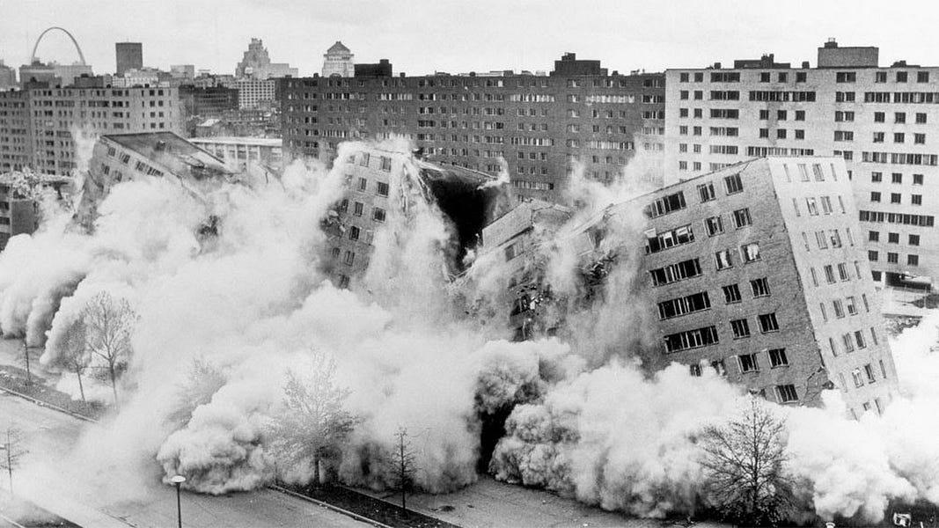
The first project, Pruitt-Igoe in St. Louis, Missouri (completed in 1954 and largely demolished by 1972), stands as one of the clearest examples of how well-intentioned modern industrial planning can create long-term urban harm. Designed as a massive public housing complex of 33 high-rise buildings, Pruitt-Igoe was a classic top-down urban renewal effort. Planners cleared “blighted” neighborhoods with the promise of progress, replacing them with dense, modernist towers meant to house thousands of low-income residents, many of them Black families displaced by earlier industrial changes. What happened next illustrates the slow violence that Rob Nixon describes so clearly. Instead of creating stable communities, the project concentrated poverty, isolated residents, and quickly deteriorated due to poor maintenance, lack of social support, and major architectural oversights. Crime, vandalism, and disrepair took over. By the late 1960s and early 1970s, the complex had become infamous for violence and low quality of life. The famous televised demolition in 1972 did not solve the underlying problems, but it instead scattered residents elsewhere, creating new patterns of informal settlement and displacement in other parts of the city. I believe that this is quite similar to what has happened with the homeless population in Phoenix in recent years.

Figure 1: The Demolition of Pruitt-Igoe, April 21st, 1972. designed by Minoru Yamasaki. Photo taken by Michael Baldridge
Pruitt-Igoe shows exactly what I am researching in Phoenix. Large-scale, top-down industrial housing solutions often ignore the human realities on the ground. They promise progress but deliver attritional harm that unfolds gradually: broken elevators, unsafe public spaces, and residents who feel trapped. The clearance of Pruitt-Igoe did not end homelessness or poverty; it simply pushed problems into new areas, much like the 2023 clearance of The Zone pushed many unhoused people toward Downtown Phoenix. In both cases, architecture created an “invisible cage,” as I described earlier. People ended up huddling in whatever shade or recessed spaces they could find, dependent on foot traffic for survival. Pruitt-Igoe reminds us that without careful attention to how people actually live and adapt, even ambitious projects become engines of slow violence.
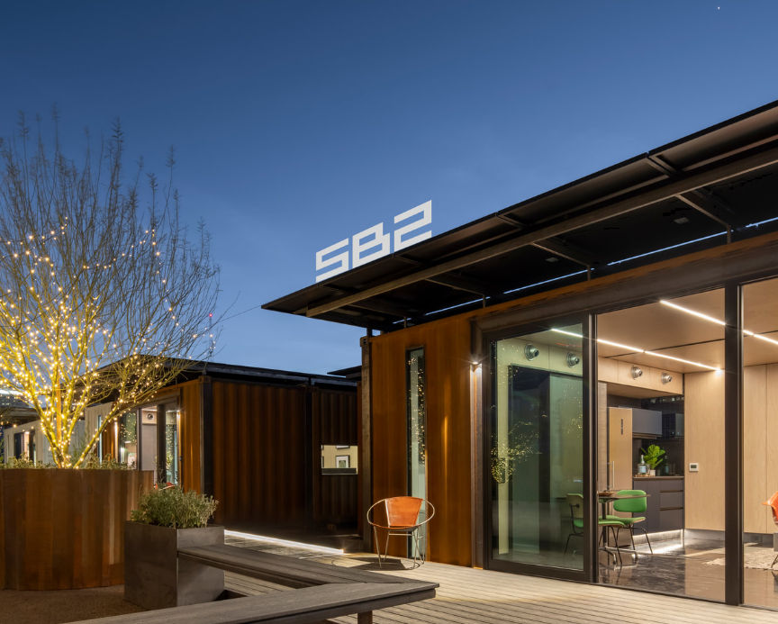
A more recent example is SB2 (and the broader Sparkbox system) by Steel + Spark, a Phoenix-based design company. SB2 is a modular, shipping-container-based housing unit designed as a one-bedroom, one-bath solution that is factory-built, craned into place, and largely off-grid. These units feature solar power, battery storage, water collection systems, high insulation, and efficient fixtures such as incinerating toilets. They are intended for quick deployment, whether as backyard ADUs, transitional housing, or small clusters. ￼I had a long conversation with Brian Stark, the owner of this company. He explained to me that these projects are motivated by the familiar problems of rampant homelessness, unsustainable housing, and a lack of flexibility in our built environment. What makes SB2 different from traditional shelters is its flexibility and focus on sustainability in extreme climates like Phoenix. The units can be placed quickly without massive site disruption, and their self-contained systems address heat, water scarcity, and energy costs head-on. In a city where concrete regularly hits 150–170°F, these modular units offer a more thoughtful approach than simply building large institutional shelters that exclude people struggling with addiction. Steel + Spark’s work shows how architects have responded to the predictable resettlement patterns I have observed, as well as addressing the major environmental crises that threaten the quality of life of Phoenix residents.

Figure 2: SB2, an off-grid, pre-assembled flexible housing designed by Steel+Spark
At the same time, SB2 still operates largely within a market-driven framework. While innovative, it risks remaining a small solution unless scaled with true community input and paired with the social services many unhoused people need. It rejects pure top-down planning with its modular design and flexible placement. However, I believe that these projects are so small-scale that it would be hard to make a true dent in the homeless population. When it comes to addressing homelessness, this project is largely responsive rather than preventative, as it is a direct response to the major urban problems caused by the rapid industrialization of The Zone. This project perfectly embodies the environmental responses needed for the future of our built environment, but it falls short of providing useful rehabilitation services to homeless individuals.
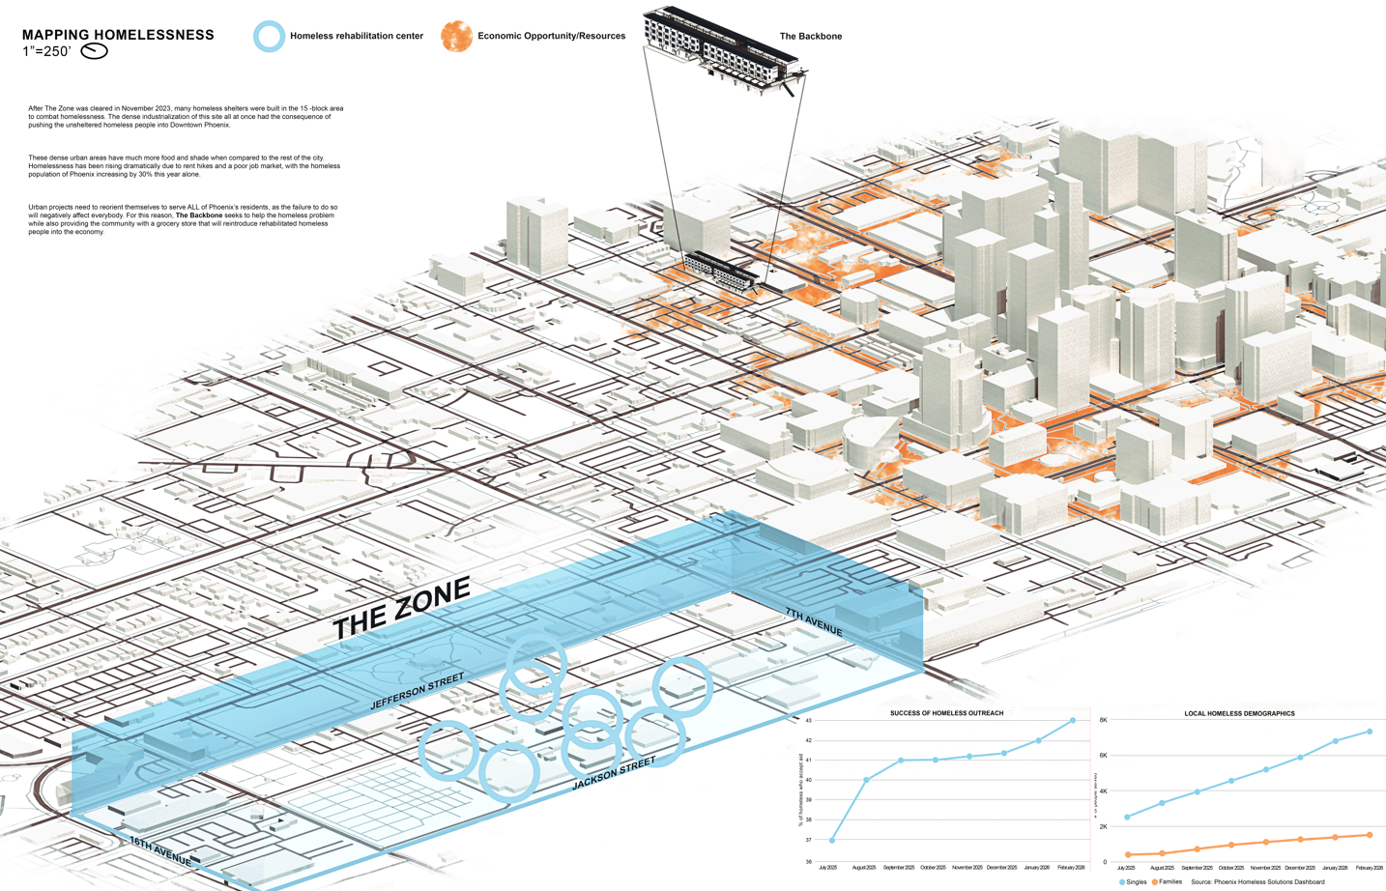
The future project that best reflects the direction I believe we should take is The Backbone, my third-year design studio final project. It is located very close to the ASU campus in Downtown Phoenix, with the aim of taking many local homeless people off the streets. This project directly responds to the clearance of The Zone and the resulting surge of homelessness in the urban core. It consists of 80 pre-assembled modular units stacked and arranged to create a supportive community environment, complete with an in-house rehabilitation clinic (including medical bays, wellness patios, and group therapy spaces), a ground-floor grocery store for the community and in-house employment, and generous spatial commons for socializing and daily life. ￼

Figure 3: Site mapping of The Zone relative to the location of The Backbone.

The design is biophilic, with open-air commons, shaded areas, and vegetation that will help combat Phoenix’s brutal heat. Biophilic design is integrated heavily in this project with the goal of reintegrating humans with nature, as doing this helps with drug rehabilitation. Water collection systems integrated with the solar roof harvest rainfall to support cooling and landscaping, addressing both environmental and electrical concerns. The modular nature allows for expansion if needed, and the short-term housing model (intended for a couple of years or less) gives people a stable base while they access rehab services, job support, and financial stability. Disability-friendly units and a clear focus on accessibility show attention to different bodies and the complex needs in the built environment. Unlike the concentrated shelters built in the old Zone area, The Backbone reweaves displaced people back into regular society and a more stable economy rather than isolating them. It creates spatial commons where group survival is dignified and elevated, as opposed to ignored and suppressed. This directly addresses the reappropriation of the spatial commons in Downtown Phoenix, as it provides a support system that addresses the many factors of the rising homeless problem that has corrupted the downtown environment. By combining housing, rehab clinic services, and a grocery store on-site, the project eliminates the need for motivated homeless people to rely solely on handouts and foot traffic. It acknowledges that architecture has downstream effects and tries to solve multiple problems at once instead of pushing them elsewhere, like was done in The Zone. I truly believe that if a number of projects like this were built, the homeless problem in Downtown Phoenix would improve massively.
When I compare these three projects, a clear trajectory emerges. Pruitt-Igoe represents the failure of mid-century top-down urbanization. SB2 shows a promising shift toward modular, climate-responsive, and quickly deployable solutions that begin to address Phoenix’s realities. The Backbone takes this further by integrating social services, economic opportunity (the grocery store), and spatial commons into a short-term rehabilitation model explicitly designed for the population displaced by projects like the Zone clearance.
These examples reinforce my central argument. Industrial and renewal projects repeatedly create predictable patterns of informal resettlement, especially in harsh climates. If architects continue designing only for current constituents and financial incentives, we will keep producing slow violence through terrible industrial projects. Projects like The Backbone demonstrate what is possible when we treat all of the city’s inhabitants, such as the unhoused people pushed into downtown by a variety of factors related to The Zone clearance, as equally important. This project shows how thoughtful, modular, supportive design can break the cycle instead of repeating it. When an area is industrialized thoughtfully and unintrusively, an entire city can feel the positive impact.

Keywords:
Reading 1: Deamer, Peggy. “Architectural Production and Consumption: Architectural Work in the Capitalist Context.”
Keyword 1: industrialization
Quote: “The crisis in identity for the builders/makers – the 19th-century change from artisan to factory-laborer – is exemplified by John Ruskin with his plea for the stone masons’ freedom to create and carve without machine-induced tropes of repetition and standardization.”
Keyword 2: consumption
Quote: “the concern for the inhabitant/consumer flourished when capitalism became preoccupied with consumption. Production/labor; consumption/user.”
Reading 2: Nixon, Rob. Slow Violence and the Environmentalism of the Poor
Keyword 3: slow violence
Quote: “By slow violence I mean a violence that occurs gradually and out of sight, a violence of delayed destruction that is dispersed across time and space, an attritional violence that is typically not viewed as violence at all.”
Keyword 4: Inequity:
“Those people lacking resources who are the principal casualties of slow violence. Their unseen poverty is compounded by the invisibility of the slow violence that permeates so many of their lives” (Nixon, p. 4). Also: “Modern environmental pollution is colonialism” via land-as-sink relations that externalize harm (Liboiron, Land, Nature, Resource, Property).
Reading 3: Dovey, Kim, and Ross King. “Forms of Informality: Morphology and Visibility of Informal Settlements.” Built Environment 37, no. 1 (2011): 11–29
Keyword 5: forms of informality
Quote: “Informal settlements are urban neighbourhoods or districts that develop and operate without the formal control of the state, co-existing but not synonymous with ‘squatter’ settlements and ‘slums.’”
Keyword 6: morphology
Quote: “There would seem to be three primary modes or processes of informal settlement growth – how settlements grow. The first is simply settling, … Second is inserting, … Third is attaching.”
Reading 4: Bélanger, Pierre. “Redefining Infrastructure.” In Ecological Urbanism, 332–41
Keyword 7: infrastructure
Quote: “They are the connective tissues and the circulatory systems of modernity. In short, these systems have become infrastructures.”
Keyword 8: crisis and conflict
Quote: “Crisis and Conflict Conditional to the redefinition of infrastructure is an understanding of its antecedents. Historically defined as the ‘collective network of roads, bridges, rail lines and similar public works that are required for an industrial economy to function,’ infrastructure in North America emerged in the early twentieth century from crisis and conflict, rather than by design.”
Reading 5: Pelger, Dagmar, Anita Kaspar, and Jörg Stollmann, eds. Spatial Commons: Urban Open Spaces as a Resource
Keyword 9: spatial commons
Quote: “Engaging with commons, those fundamental natural and cultural resources that serve a community’s wellbeing, also requires coming to terms with spaces.”
Keyword 10: third space
Quote: “This shared ownership establishes a ‘third space’ between public resource space, which is potentially freely available, and the privatized space used by individuals or corporations.”
Reading 6: Virilio, Paul. “The Overexposed City.” In Architecture | Theory | since 1968, 580–91
Keyword 11: overexposed city
Quote: “For in the overexposed city, the architectural organism is no longer opaque, occlusive, and inscribed with visible information, but porous and vulnerable to the intrusion of forces that are no more visible than an electron.”
Keyword 12: within and without
Quote: “the notions, central to architecture, of within and without, which are gradually losing their importance.”

Trajectory/Research Observations
For my research surrounding this project, I walked through the Western side of Downtown Phoenix, and towards The Zone, cataloging and categorizing how these informal settlement patterns are direct responses to the hasty industrialization of local architecture. Before this experience, I imagined potential examples of this as homeless people occupying abandoned buildings, new skyscrapers creating larger swaths of shade, or people repurposing spaces for living that were previously used for something else. However, I had no idea how deep the disconnect is between the lifestyles and industries that homeless people in Downtown Phoenix engage in outside of public awareness. On May 9th, I interviewed 10 homeless people in the center of Downtown Phoenix, all of whom gave me unique insights into the street-level perspectives and motivations of those trying to survive in the hottest city in the country. I discussed lifestyle, survival tactics, world views, and ideas for the future relating to architecture and urbanization with a wide range of homeless people, including a heroin addict, a starving artist, and even a drug dealer. After my first conversation with a man who called himself “Block,” I realized I had underestimated the top-down negligence involved in the rapid industrialization of The Zone. Block told me that he had been homeless in Phoenix for the last 5 years, and he explained to me that he can no longer live or sleep in The Zone due to the rules and regulations surrounding the requirements for getting a bed in a homeless shelter. Block is addicted to heroin, and he explained to me that ever since The Zone was developed, he has been primarily living in the heart of Downtown Phoenix. After all, this is the “nicest” part of the area, with the most economic opportunity and survivability by far. Unfortunately, the resettlement of thousands of homeless people has made these beautiful urban environments feel less secure for everybody else. Not only did I see fountains get reappropriated as public baths, but also concrete benches get used as privacy barriers for individuals to do drugs without being seen by passing cars on the street. The shaded regions of public parks were peppered with sleeping homeless people, taking refuge from the sun. Under one of these trees, I met another man who introduced himself as “Fast”. He explained to me that the parks in Downtown Phoenix have become social hubs for homeless people to congregate. Along with 7/10 of the homeless people I talked to, he too had been living in The Zone before rapid industrialization in 2023. I have never seen a class of people who live in the same built environment as regular people that are so excluded from the rest of the luxuries of a regular life. A few of the men I spoke with mentioned that they were not used to being treated like humans, as they felt they were always treated as invisible and subhuman. This greater urban system is a vicious cycle, as the homeless population on the street is naturally filtered to be comprised mostly of drug addicts, mentally ill, and criminals. The behavior they engage in to survive can be morally bankrupt, but it is harder to judge them after realizing the situation was exacerbated by poor urban planning. I had a brief conversation with a homeless man who explained to me that he survived by selling drugs in the parks in Downtown. Since the industrialization of The Zone, new industries such as this one have sprung up in Downtown Phoenix, reappropriating the spatial commons as a place for illegal transactions. Every homeless person I talked to had a hustle, trying to make a couple of dollars by selling anything they could. One of the capitalists I met was a man selling prepaid smartphones for 20 dollars apiece. Along with the other salesmen, he was peddling his product in a large public park. After doing this on-site research, I realized that not only does hasty industrialization drive informal resettlement patterns, but it also drives a wide range of smaller industries that create an underground marketplace in Phoenix’s spatial commons. These spatial commons are places where collective survival is sustained by natural resources. As a whole, I believe that the short-sighted planning of The Zone created a more destructive and more permanent problem that is now much harder to solve. The Zone will always be “The Zone” now that it has been reestablished as the city’s largest center for homeless aid. In an area like The Zone, the neighborhood's financial health declined significantly as the area became overrun with homeless. This economic situation is what is known as a “consumption city”, where industrialization created a place where people will only consume and not produce anything productive. The creation of many homeless rehabilitation centers all in one place solidified this area as an unsustainable “consumption” economy that creates financial liabilities for taxpayers. In conjunction with this, the public parks will likely remain home to loose homeless communities for the foreseeable future. This trend supports my idea that hasty urbanization creates unstable consumption dynamics that inadvertently push vulnerable, unstable people into survival economies in different parts of the city. Unfortunately for the people of Phoenix, this dense top-down planning led to the mass displacement of the most troubled members of the unhoused population. Migration can be understood more easily through the lens of infrastructure rather than laws or the labor market, as the homeless population lives outside of both of those constraints. I believe that, given humans’ inelastic demand for food, water, and shelter, the negative externalities of The Zone’s industrialization were common sense if one thought the problem through. It is predictable that homeless shelters’ selection filters would lead to major population drifts.
To better understand this issue, I want to present an alternative solution that would address the shortcomings of The Zone’s industrial planning. I want you to imagine that instead of funding 8 homeless shelters right in the same area, the city funded homeless shelters that were more spread out. This decentralization of the homeless infrastructure would lead to a much less robust network of illegal transactions between homeless people in the center of Downtown Phoenix, as the driving force of that informal market would fall away. Funding rehabilitation centers that reintegrate the homeless population back into our society organically in a variety of different areas would not only reweave them into the economy, but would also break down the deep social stigma associated with homelessness. I believe that a big part of this stigma comes from how we perceive these homeless people in our built environment, as well as poor behavior driven by bad living conditions. Bringing homeless people out of The Zone organically and slowly would have had far fewer downstream effects on the urban environment, because the top-down planning of this development did not account for human nature. Homeless people respond to their environments according to their needs, and the architectural elements of the major urban centers in which they live are repurposed for surviving instead of living. The City of Phoenix treated the homeless population like a number on a chart as opposed to a population of adaptable, desperate people who would change their behavior based on their immediate needs. This research required skills in site mapping, ethical interviewing, economic analysis, and critical writing. Two upper-division courses that would support this trajectory are the Emergent Landscapes Studio with Jesus Robles and Beth Weinstein’s advanced studio. I found this project very inspiring, as I was able to apply my ideas across a variety of mediums, including statistical analysis, journalism, and social activism.

3.0 Project Resources
Bibliography

Bikis, Addis, and Digvijay Pandey. "Squatter Settlement and Informal Urbanization: Causes and Consequences." Environmental Science and Pollution Research 30, no. 9 (2023): 23276–23294.
Blair, Matthew. "Enhancing Human Health and Recovery Through Biophilic Design." PhD diss., University of Massachusetts Amherst, 2012.
Davies, Thom. "Slow Violence and Toxic Geographies: 'Out of Sight' to Whom?" Environment and Planning C: Politics and Space 40, no. 2 (2022): 1–18. https://doi.org/10.1177/23996544221085981.
Gollin, Douglas, Rémi Jedwab, and Dietrich Vollrath. "Urbanization with and without Industrialization." Journal of Economic Growth 21, no. 1 (2016): 35–70.
Nixon, Rob. Slow Violence and the Environmentalism of the Poor. Cambridge, MA: Harvard University Press, 2011.
O’Lear, Shannon. "A Research Agenda for Geographies of Slow Violence." In A Research Agenda for Geographies of Slow Violence, edited by Shannon O’Lear, 1–22. Cheltenham, UK: Edward Elgar Publishing, 2021.
Pelger, Dagmar, Anita Kaspar, and Jörg Stollmann, eds. Spatial Commons: Urban Open Spaces as a Resource. Basel: Birkhäuser, 2017.
Pinar, Ekin. "Entangled Histories of Architecture and Dispossession in The Pruitt-Igoe Myth (2011)." (2025).
Shelton, Amy, and Dorothy Rohde-Collins. “Urban Renewal’s Educational Legacy: Black Displacement and School Segregation from Mill Creek to Pruitt-Igoe.” PRiME Center, Saint Louis University. April 4, 2025. https://www.primecenter.org/prime-blog/urban-renewal-in-education.
Steckel, Richard H., and Roderick Floud, eds. Health and Welfare during Industrialization. Chicago: University of Chicago Press, 1997.
Xiang, Biao, and Johan Lindquist. "Migration Infrastructure." International Migration Review 48, no. S1 (2014): 122–148.

Katherine Davis-Young, “Metro Phoenix Unsheltered Homeless Population Spiked 28% This Year as Shelter Funding Dried Up,” KJZZ, May 28, 2025, https://www.kjzz.org/kjzz-news/2025-05-28/metro-phoenix-unsheltered-homeless-population-spiked-28-this-year
Nixon, Rob. (2011). Slow violence and the environmentalism of the poor. Harvard University Press.
O’Lear, Shannon. (2021). A research agenda for geographies of slow violence. In S. O’Lear (Ed.), A research agenda for geographies of slow violence (pp. 1–22). Edward Elgar Publishing. https://doi.org/10.4337/9781789904376.00005
Steckel, Richard. H., & Floud, Roderick (Eds.). (1997). Health and welfare during industrialization. University of Chicago Press.
Dovey, Kim, and Ross King. “Forms of Informality: Morphology and Visibility of Informal Settlements.” Built Environment 37, no. 1 (2011): 11–29.
Pelger, Dagmar. “Spatial Commons. Urban Open Spaces as a Resource.” Spatial Commons #1, 2017.
Douglas Gollin, Rémi Jedwab, and Dietrich Vollrath, “Urbanization with and without Industrialization,” IIEP-WP-2014-1 (Institute for International Economic Policy, Elliott School of International Affairs, The George Washington University, October 2013), 1–4.
Urbanization with and without Industrialization (Gollin, Jedwab, Vollrath)
Migration Infrastructure (Xiang & Lindquist)
Spatial Commons. Urban Open Spaces as a Resource (Pelger)
Nixon, Rob. Slow Violence and the Environmentalism of the Poor. Harvard University Press, 2011.
Steckel, Richard H., and Roderick Floud, eds. Health and welfare during industrialization. University of Chicago Press, 2008.
Amy Shelton and Dorothy Rohde-Collins, “Urban Renewal’s Educational Legacy: Black Displacement and School Segregation from Mill Creek to Pruitt-Igoe,” PRiME Center, Saint Louis University, April 4, 2025, https://www.primecenter.org/prime-blog/urban-renewal-in-education.
Pinar, Ekin. "Entangled Histories of Architecture and Dispossession in The Pruitt-Igoe Myth (2011)." (2025).
Blair, Matthew. "Enhancing Human Health and Recovery Through Biophilic Design." PhD diss., University of Massachusetts Amherst, 2012.

